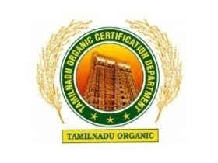

TAMIL NADU ORGANIC CERTIFICATION DEPARTMENT
(TNOCD)
ANNUAL CROPPING PROGRAMME

Registration No :
Name of the Farmer :
Address :

Area in (ha)
S.NO | Perennial Crops |  | Annual Crops
S.NO |  |  | Kharif |  | Rabi |  | Summer
S.NO | Crop | Area | Crop | Area | Crop | Area | Crop | Area

Signature of the Farmer

